AIM
Activity Gl Period Status Detail
MD.120 deployment Instructions
Raya International Services

Author: Motike Rahul Vardhan
Creation Date: March 24,2025
Last Updated:
Version: 1.0

Creating the OIC Integration for Gl Period Status Detail

Creating the connection:
- First we need the create the connection for soap and ftp before creating the oic connection.
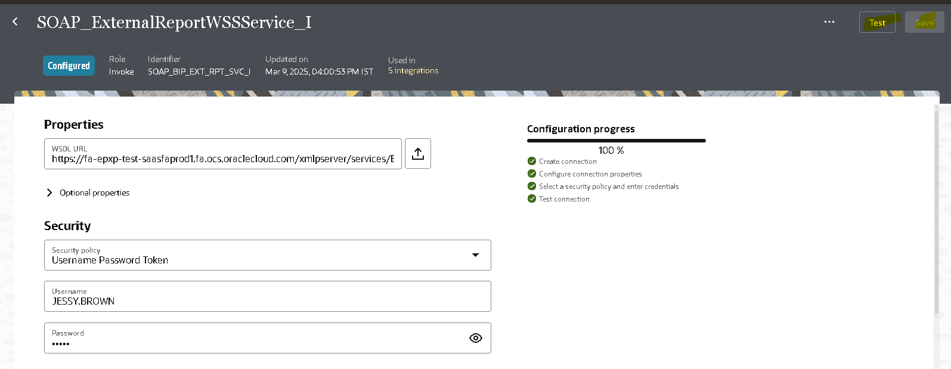
- Here we need to give the soap connection to the username,Url and password to it.
- Click on the test where if the configuration process is 100% then we can save it and use it for the connection.
- Url for gl Period status is : https://fa-epxp-test-saasfaprod1.fa.ocs.oraclecloud.com/fscmService/ErpObjectAttachmentService?WSDL

- We need to create the ftp connection for it.

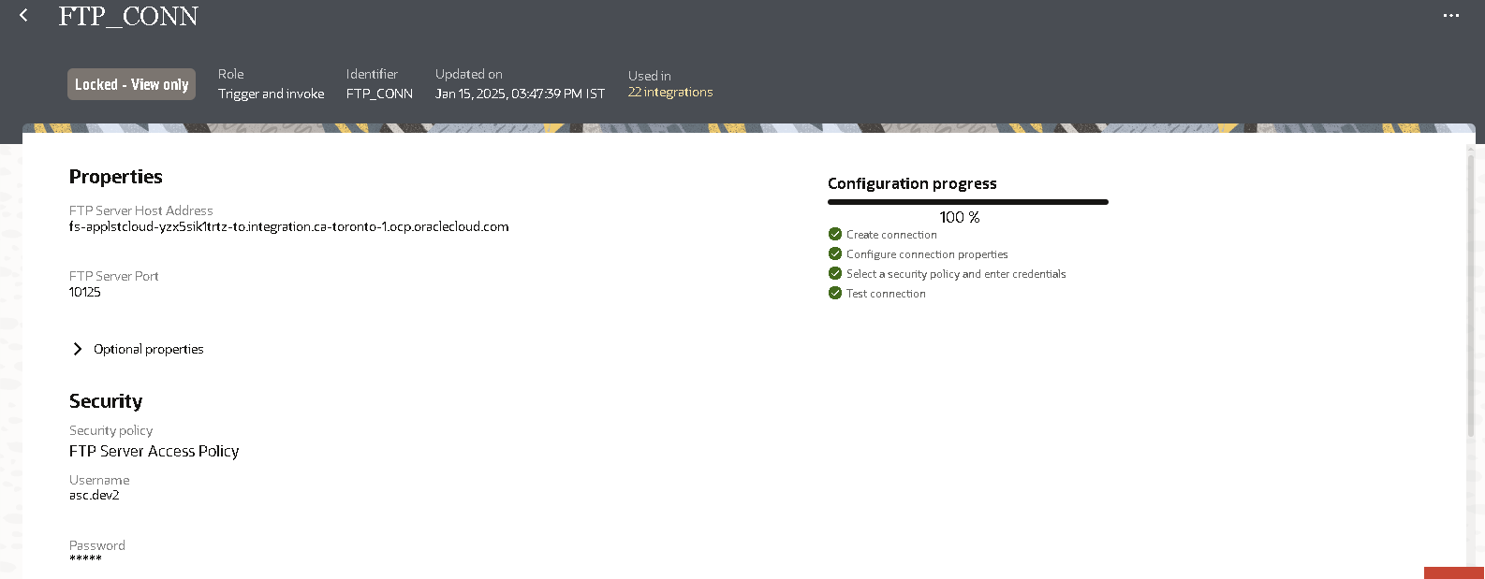
- Here we have given the ftp connection where we have configured the 100% by giving the username and password for it.

Creating the report for the Gl periods Data:

- Firstly we need write a query to get the details of the supplier for it.
- Then we need to create the data model with the query in the oracle fusion instance.
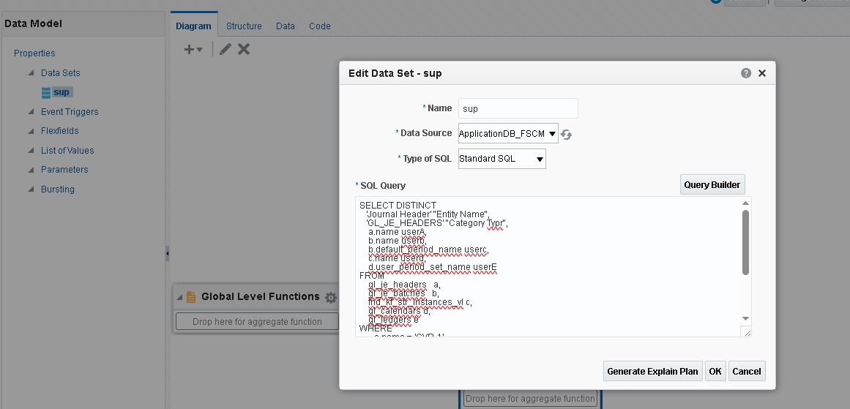
- After creation of the data model then we need to create Report for it.
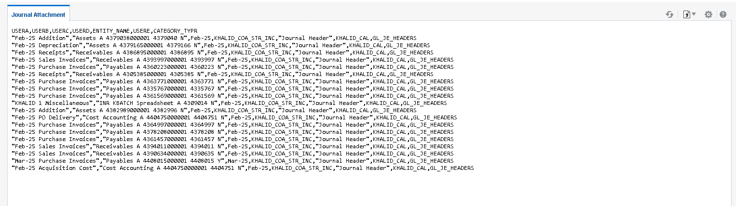
- The data is uploaded in the csv format for it.

Report Data model

Developing the Application Integration:

Go to the design and click on the create then select the application integration process.
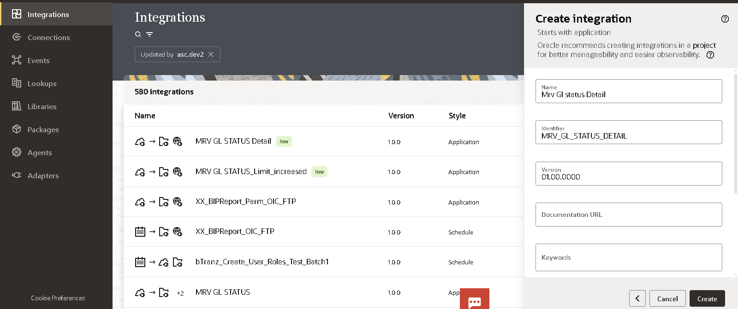
Here giving the rest connection to the catch the count the journals the attachments are uploaded.
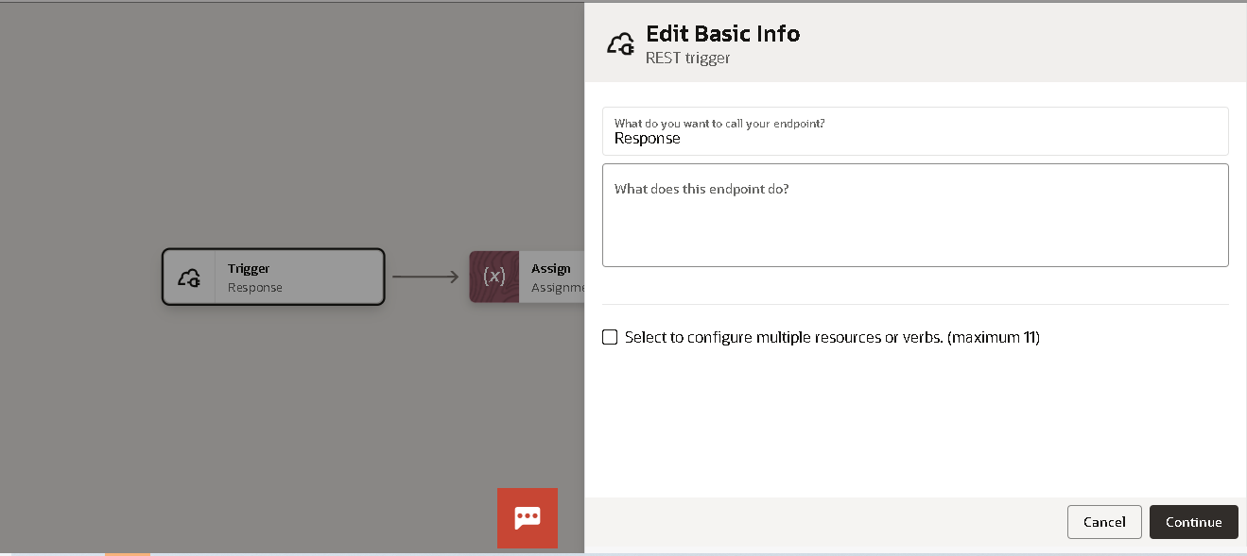
Given the get method and added the response payload to it. The Response will be collected at the end where as success. The Response is defined in the map.

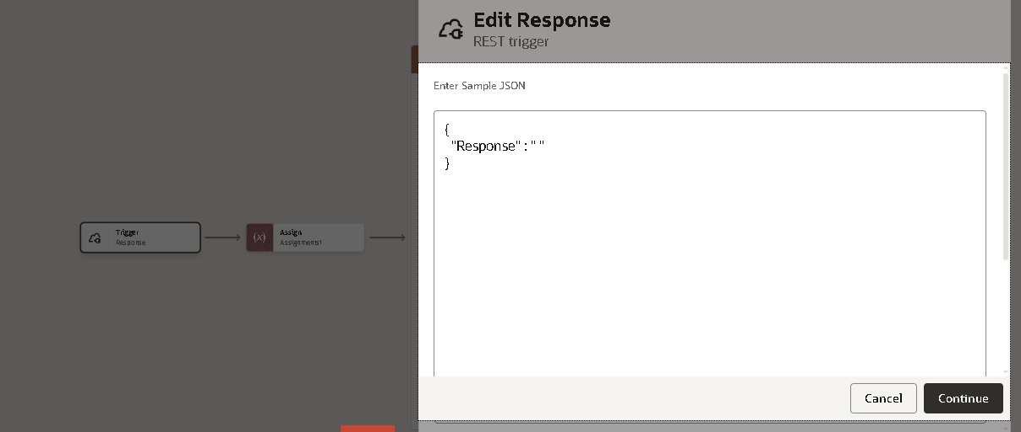

Calling the BI Report for the Gl periods Data:

Selecting the run report option where running the report of connect with the soap connection in oic instance and in the oracle OIC.
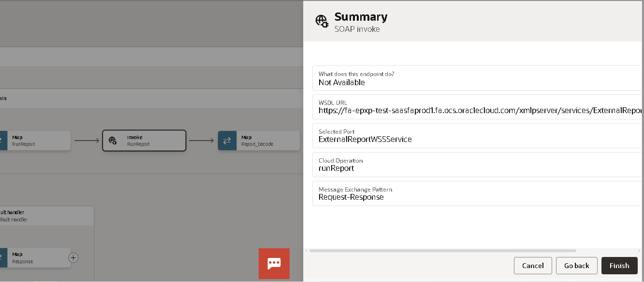
Calling the Soap Api to run the External Report WSS Service and select the Run Report Option.
Decoding the Report output in the xml format and placing File name and file directory and uploading the xsd format.
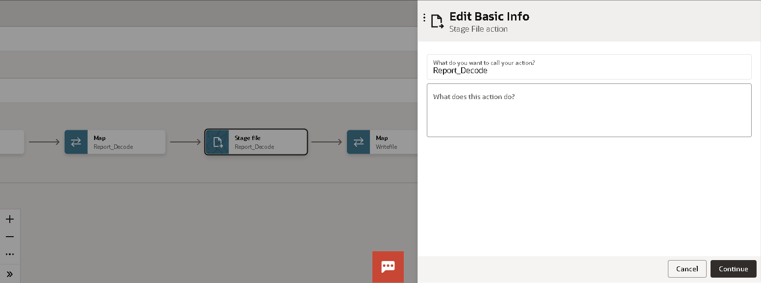

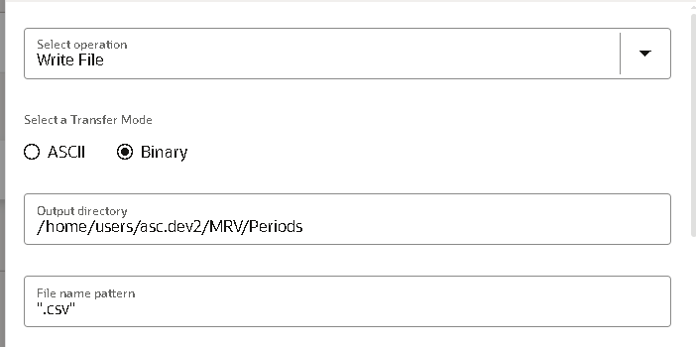
Here this it will run the report and place the file in the Ftp by using the FTP Connection.
Selected the write file option and specified the output directory and the file name pattern.
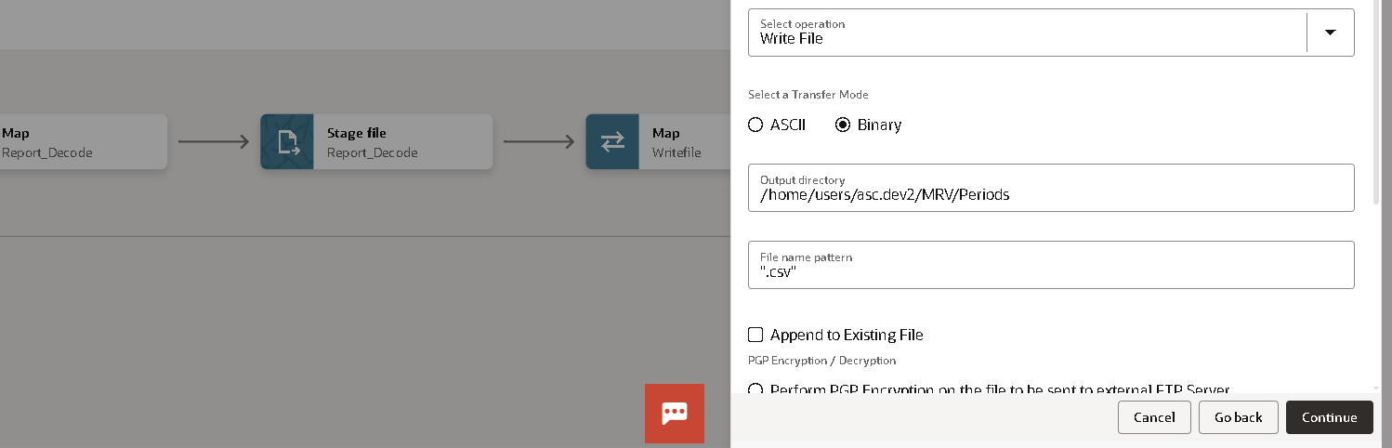
File structure is not selected the ics file is placed to get into it.
To placed into the specified path.
The File is selected in the output path to get into the FTP File.
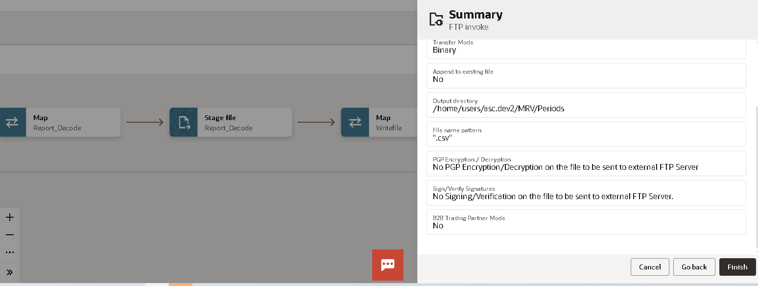
The path of the File Reference is here.
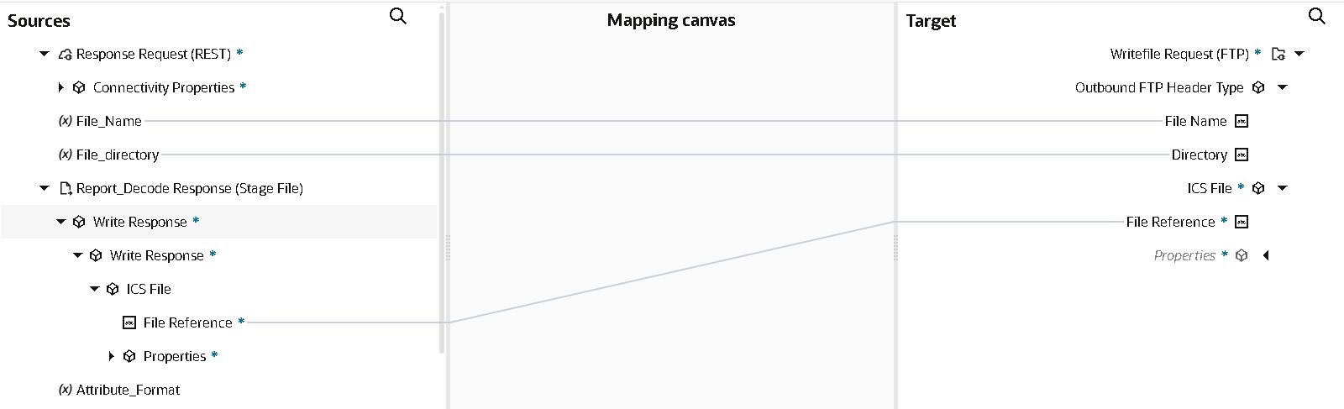

Here the Fault Handler will be placed default handler to map into the Soap connection reason will be placed in the output.
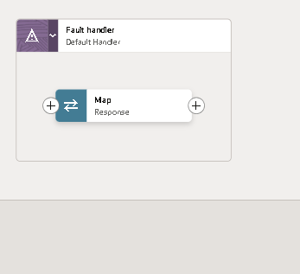
The Response will be catched and addressed in it.
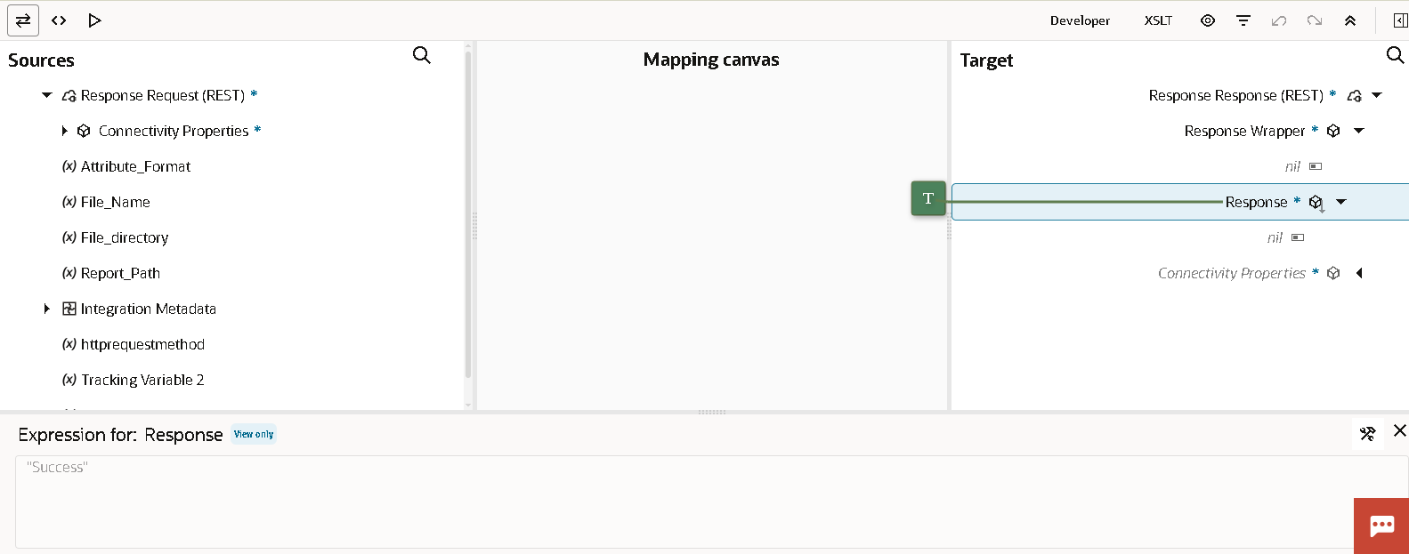

The integration will be activated and run the report to it.
The OIC Integration File of GL Period Status :

